Exam Questions for QC Fall2020

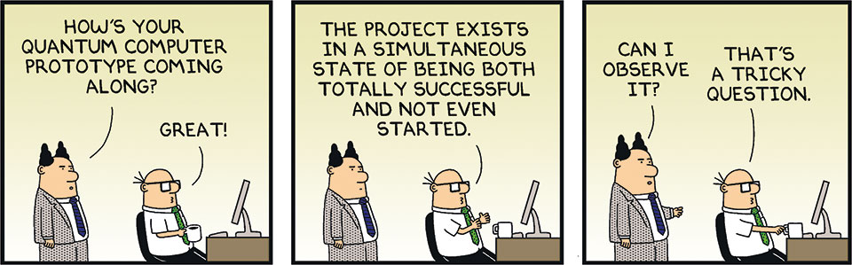

Indhold

About the KEA-PBA-Quantum Computing EXAM 4

Report 5

Mathematics 5

1. Hadamard gate and superposition 5

2. Operate Pauli gate X on a vector 5

3. Operate Pauli gate Y on a vector 5

4. Operate Pauli gate Z on a vector 5

5. BRA and KET notation 5

6. Unitary operation 5

7. Hadamard and CNOT for entanglement 5

CodeRanch 5

Multiple choice 7

Optional Supplementary questions and answers to fill out the 30 minutes 12

# About the KEA-PBA-Quantum Computing EXAM

***Dear Ms and Mr Quantums,***

I’m sorry to realize that the Quantum show is nearly over for this semester. It has been a great pleasure for meto meet all of You including Your ability contribute to this course by all means – I will miss You. ☺

Anyway we are going to finalize this semester by having a party, (by ignorants called an exam).

You are probably among the first PBA’s grading on the topic ***Quantum Computing*** in Europe or maybe the entire World – but definitely not the last. During the Year’s to come there will be a lot of competitors at Your level, but for the time being You have a ***head to start*** during the next 3 Years – I suppose.

So stay tuned and prepare for exam, this time before Christmas in the most delightful and seductive way ☺ - *I always did !!!!!*

My Mobile will be open for You about Your concerns regarding the exam 23 29 11 21

The agenda for You to prepare and present will be in the following order during the examination by censor and me as examinator.

The examination will be held in 4 parts and you will get points for the total score as follows

1. Report or Topic presentation – Mandatory for passing the exam points [0-7]
2. Mathematics questions – choose one of eight points [0-2]
3. Coderanch presentation of Your ovn choice points [0-2]
4. One Multiple choice question points [0-1]

**In total score points [0-12]**

**Notice – the total score will be round down as follows**

1. Will be round down to 0
2. Will be round down to 2
3. Will be round down to 2
4. Will be round down to 4
5. Will be round down to 4
6. Will be round down to 4
7. Will be round down to 7
8. Will be round down to 7
9. Will be round down to 7
10. Will be round down to 10
11. Will be round down to 10
12. Will be round down to 12

# Report

Tell us about Your report or a self chosen topic in 15-20 minutes for Datamatikers and 25-30 minutes for PBA’s

# Mathematics

Select a slice of paper with *hidden topics* on the exam-table, *topics* You have already prepared at home for this part of the exam.

Tell us about the topic You have just chosen, about mathematics, for about 3-5 minutes.

The intention is that the student elaborate on a selected topic with a linear algebraic purpose.

*An example could be - Like showing us what happens if You try to decide if it is a unitary transformation actual get’s a phase to flip etc..*

Topics for the exam below:

## Hadamard gate and superposition

## Operate Pauli gate X on a vector

## Operate Pauli gate Y on a vector

## Operate Pauli gate Z on a vector

## BRA and KET notation

## Unitary operation

## Hadamard and CNOT for entanglement

# CodeRanch

Select a slice of paper with *hidden topics* on the exam-table, *topics* You have already prepared at home for this part of the exam.

Tell us about the topic You have just chosen, about code, for about 3-5 minutes.

Using the Q-Experince Development Platform, Qiskit and Jupyter Notebooks platform, the student must be able to explain the relationship between a Quantum Computer chart and the subsequent python code executed.

Topics for the exam below:

1. Hadamard
2. X-gate
3. Y-gate
4. Z-gate
5. Identity-gate
6. Controlled-Not

Find the examples in Fronter under EXAM\CODERANCH including Jupyter Notebook examples that You possibly could use in the actual exam-situation – it’s up to You to decide anyway ☺

# Multiple choice

Answer the question max 1 minutes

There will be 13 different choices and You will choose only one question

Question 1 :

A Qubit is a _________ quantum mechanical system.

a) 2-state

b) 3-state

c) 4-state

a)(Right)

Question 2 :

Which of the following shape can be used to the pure state space of a 2-level quantum system?

a) Rectangle

b) Cylinder

c) Bloch-Sphere

d) Cube

c) (Right)

Question 3 :

Does a quantum computer perform Boolean logic (AND, OR, NOT with true and false — not to be confused with binary digits of 0 and 1),

such as evaluating complex conditions, comparable to a traditional digital computer?

a) Yes

b) No

c) Yes and No

c) (Right)

Question 4 :

How is Quantum bit stored when measured by Quantum Operators?

a) In a Classical memory

b) In a Quantum memory

a) (Right)

Question 5 :

Is room temperature quantum computing theoretically practical?

a) No

b) Yes

b) (Right)

Question 6 :

What is the main difference between a classical bit and a qubit?

a) Qubits can be in two states at the same time

b) Qubits are able to store more data than bits

c) Qubits cannot be run in parallel

d)There is no difference, a qubit simply represents a bit

answer: a

Question 7 :

What is the quantum equivalent of the classical NOT gate?

a) Hadamard Gate

b) Pauli-X Gate

c) SWAP Gate

d) CNOT Gate

answer: b

Question 8 :

How long does it take for communication to travel between a quantum entangled pair?

a) speed of light time between the entangled pair

b) Instantaneously

c) They don’t communicate with each other

b) (Right)

Question 9 :

How can interference be used in a quantum computation like Shor's algorithm?

a) We make sure all the wrong answer interferes with each other and cancels out

b) It proves that the superposition is compromised, and we need to restart the computation

c) It serves no purpose

d) The interference will amplify the correct result and drown out the wrong

a) (Right)

Question 10 :

How many qubits does CNOT-gate take as input?

a) 1

b) 2

c) 3

d) Any number of qubits

b) (Right)

Question 11 :

What is a tensor product of two qubits?

a) The tension between two qubits

b) The state of the combined system of two qubits

c) The angle between two qubits

d) The inner product of two qubits

b) (Right)

Question 12 :

What does Heisenbergs Uncertainty Principle state?

a) The entanglement is uncertain until you measure it

b) The velocity is uncertain unless you also measure position

c) It is possible to measure both a particle's velocity and position

d) It is not possible to measure both a particle's velocity and position

d) (Right)

Question 13 :

What happens if you execute two Hadamard gates to |0>?

a) 1 / 2

b) -1 / 2

c) |0>

d) |1>

c) (Right)

# Optional Supplementary questions and answers to fill out the 30 minutes

|  |  |
| --- | --- |
| 1. what stands EPR for | Einsten,Podolsky and Rosen |
| 1. Show us an example of a KET | l0> or l1> |
| 1. What do we call the experiment where You prove whether the theory behind the EPR is right or wrong | CHSH game (your exercise at DTU) |
| 1. What is the idea about a unitary tranformation | Pauli gates times each other results in a unitary matrix. If a Gate is unitary it’s a genuine Quantum Gate |
| 1. Show us an example of a unitary transformation | Ex Pauli like: Not*Not, |
| 1. Show us how a Hadamard works with at KET zero | Zero to a 45 degree angle of the vector |
| 1. How can You prove that the Hadamard is a true Quantum Gate - Show us | H*H = a unitary matrix |
| 1. Show us an example of an entangled wavefunction | lψ> = αl00> + βl11> |
| 1. What is a Bell state, show us an example | lψ> = αl00> + βl11> |
| 1. How many Bell states are there | 4 |
| 1. How do You create an entangled state with Quantum Gates | a Hadamard and a CNOT |
| 1. which gate du You use to set a qubit in a superpositioned state | The hadamard gate |
| 1. What happens when You sense on a qubit | It collapses to a classical 0 or 1 |